Matthew Clem
IT 230
Professor Satterfield
8 February 2026

Program Output Screenshots

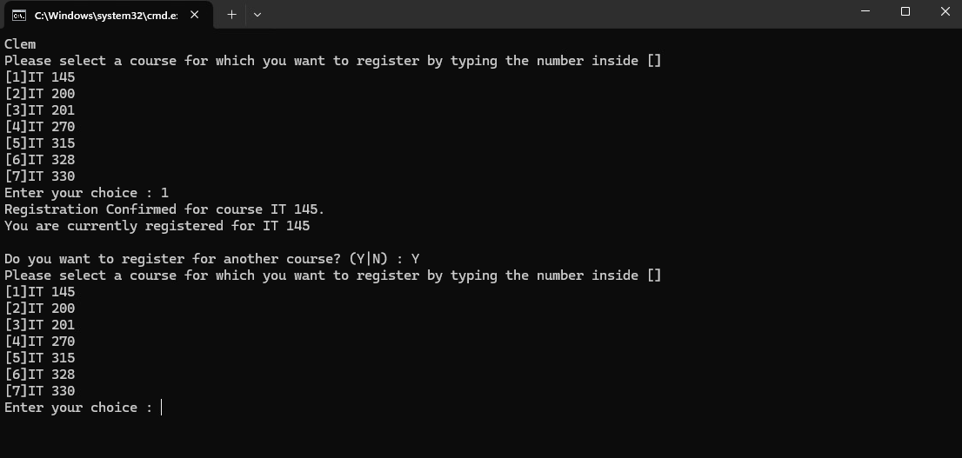
This screenshot shows a successful registration for the IT 145 course.

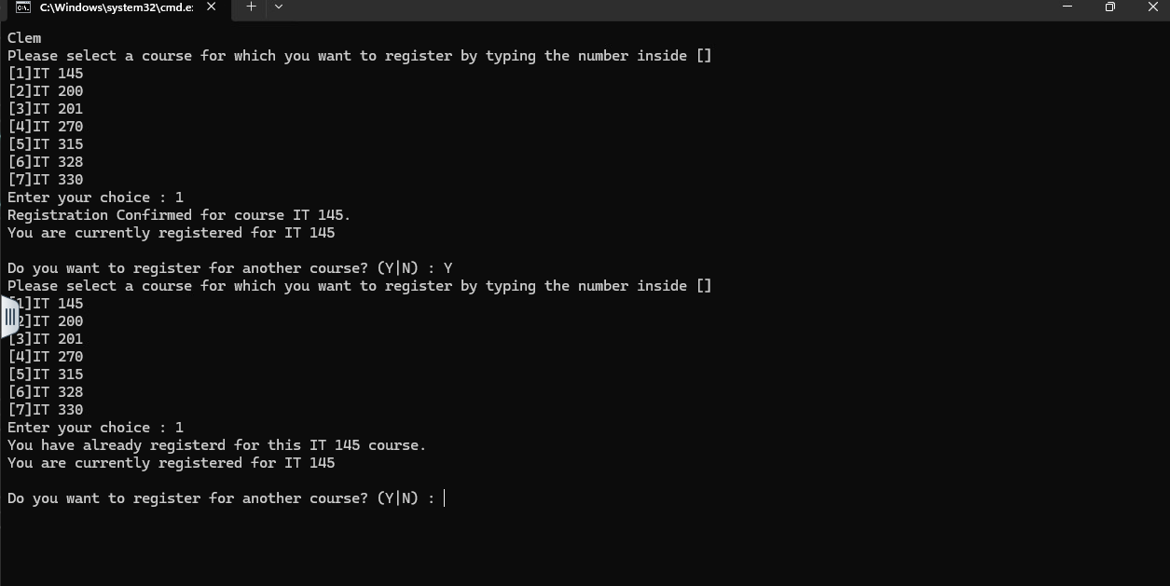
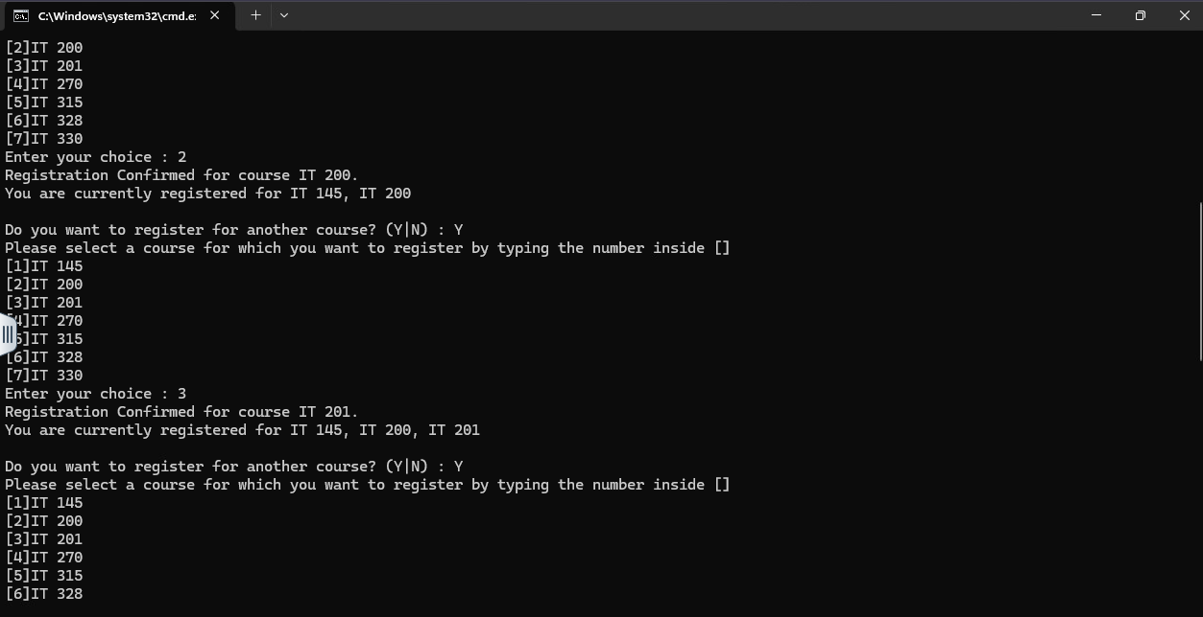
This screenshot shows that the program prevents duplicate course registrations by displaying an error message when a student attempts to register for the same course more than once.

This screenshot shows that the student has successfully registered for multiple courses.

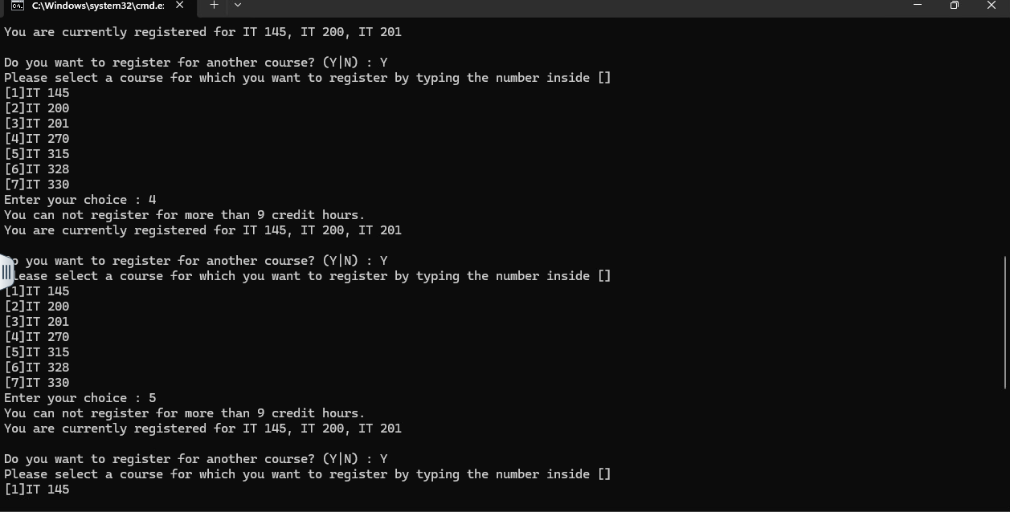

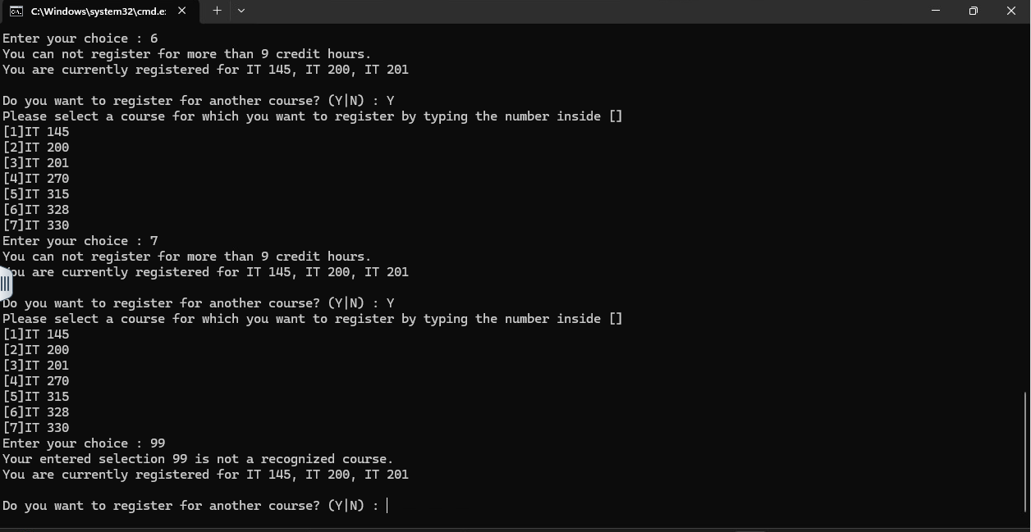
This screenshot shows that the program enforces the maximum credit hour limit to no more than 9 hours.

This screenshot shows that the program rejects an invalid course selection.

Source Code- Program.cs :
using System;

namespace ConsoleRegisterStudent
{
class Program
{
static void Main(string[] args)
{
(new Program()).run();
}

void run()
{
int choice;
int firstChoice = 0, secondChoice = 0, thirdChoice = 0;
int totalCredit = 0;
string yesOrNo = "";

Console.WriteLine("Clem");

do
{
WritePrompt();
choice = Convert.ToInt32(Console.ReadLine());

switch (ValidateChoice(choice, firstChoice, secondChoice, thirdChoice, totalCredit))
{
case -1:
Console.WriteLine("Your entered selection {0} is not a recognized course.", choice);
break;

case -2:
Console.WriteLine("You have already registerd for this {0} course.", ChoiceToCourse(choice));
break;

case -3:
Console.WriteLine("You can not register for more than 9 credit hours.");
break;

case 0:
Console.WriteLine("Registration Confirmed for course {0}.", ChoiceToCourse(choice));
totalCredit += 3;

if (firstChoice == 0)
firstChoice = choice;
else if (secondChoice == 0)
secondChoice = choice;
else if (thirdChoice == 0)
thirdChoice = choice;

break;
}

WriteCurrentRegistration(firstChoice, secondChoice, thirdChoice);

Console.Write("\nDo you want to register for another course? (Y|N) : ");
yesOrNo = (Console.ReadLine()).ToUpper();

} while (yesOrNo == "Y");

Console.WriteLine("Thank you for registering with us");
}

void WritePrompt()
{
Console.WriteLine("Please select a course for which you want to register by typing the number inside []");
Console.WriteLine("[1]IT 145\n[2]IT 200\n[3]IT 201\n[4]IT 270\n[5]IT 315\n[6]IT 328\n[7]IT 330");
Console.Write("Enter your choice : ");
}

int ValidateChoice(int choice, int firstChoice, int secondChoice, int thirdChoice, int totalCredit)
{
// Only menu options 1-7 are valid
if (choice < 1 || choice > 7)
return -1;

// Prevent duplicate registration
if (choice == firstChoice || choice == secondChoice || choice == thirdChoice)
return -2;

// Prevent registering more than 9 credit hours (3 courses)
if (totalCredit >= 9)
return -3;

// Valid selection
return 0;
}

void WriteCurrentRegistration(int firstChoice, int secondChoice, int thirdChoice)
{
if (firstChoice == 0)
{
Console.WriteLine("You are currently not registered for any courses.");
}
else if (secondChoice == 0)
{
Console.WriteLine("You are currently registered for {0}", ChoiceToCourse(firstChoice));
}
else if (thirdChoice == 0)
{
Console.WriteLine("You are currently registered for {0}, {1}",
ChoiceToCourse(firstChoice), ChoiceToCourse(secondChoice));
}
else
{
Console.WriteLine("You are currently registered for {0}, {1}, {2}",
ChoiceToCourse(firstChoice), ChoiceToCourse(secondChoice), ChoiceToCourse(thirdChoice));
}
}

string ChoiceToCourse(int choice)
{
string course = "";
switch (choice)
{
case 1:
course = "IT 145";
break;
case 2:
course = "IT 200";
break;
case 3:
course = "IT 201";
break;
case 4:
course = "IT 270";
break;
case 5:
course = "IT 315";
break;
case 6:
course = "IT 328";
break;
case 7:
course = "IT 330";
break;
default:
course = "";
break;
}
return course;
}
}
}

